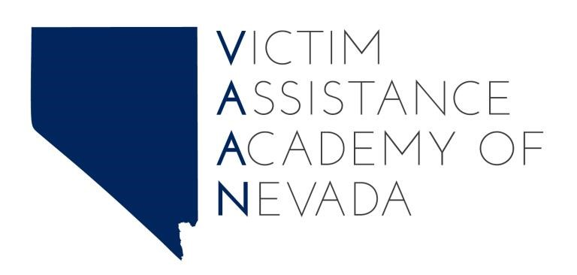
2022 Victim Assistance Academy of Nevada Student Application
The Division of Child and Family Services, in partnership with Washoe County District Attorney’s Office, Nevada Coalition to End Sexual and Domestic Violence, Nevada Attorney General’s Office, Nevada
Victims of Crime Compensation Program, Clark County District Attorney’s Office, Las Vegas Metropolitan Police Department, and The Center are planning and hosting a 40-hour Virtual State Victim Assistance Academy May 1, 2022 – July 31, 2022.
Application due date: April 15, 2022
Complete form electronically at: https://hal.nv.gov/form/DCFS/2021_Victim_Assistance_Academy_of_Nevada_Student_Application

The goals of the academy are to:
- Encourage diverse participation.
- Provide an experiential format for learning.
- Utilize a diverse faculty of victim service practitioners who have expertise in various victim issues, and staff from other agencies that support victim intervention and restoration; and
- Continuously evaluate student feedback and experiences to improve future academies.
The benefits of attendance will be:
- An increase in knowledge and skills related to serving victims of crime.
- Professional growth from VAAN’s victim-centered curriculum and innovative adult learning techniques.
- Create new and strengthen existing relationships with other victim service professionals across Nevada and U.S.
Student Eligibility:
- Applicant is a direct provider of victim services.
- Applicant serves in a paid victim services position; or, a volunteer that works in a staff capacity.
- Applicant has the support of his/her supervisor to attend the entire Academy.
- Access to computer to complete virtual training

All applications will be reviewed by the Student Selection Committee who will engage in a process intended to promote an academy class which reflects a balance in cultural, programmatic, professional, and geographic diversity. No more than 35 participants will be selected to attend this Academy. Please be advised that if more than one person from your agency applies, your supervisor may be asked to prioritize attendance decisions for the Student Selection Committee.
2022 Victim Assistance Academy of Nevada (VAAN) Application

Name:
Organization/Agency:
Position:
Address:
City, State, Zip:
Phone Number:
Email:
County or Counties Served:
Does your organization/agency receive VAWA or VOCA funding? If so, please indicate which.
Who is the fiscal authority at your organization/agency? (Name, Email, Phone)
Do you provide direct services?
Number of years of experience in direct victim services:

Education level:
High school diploma Some college Bachelor’s degree GED Associate’s degree Advanced degree
Which of the following best describes your agency?
Non-profit agency Tribal entity
Private, for profit Local, state or federal government
Other (please specify): _____________________________________________________
Which of the following best describes the field in which you work?
Victim services Health/human services Substance abuse services
Law enforcement Hospital/medical Mental health services
Prosecution Education Legal services
Correction/probation Childcare Youth services Other (please specify): _____________________________________________________

Indicate your primary area(s) of focus for which you were hired? (Please check all that apply):
Assault Robbery Hate/bias crimes
Child abuse Gang violence Trafficking
Domestic violence LGBTQ victims Kidnapping
Sexual assault/abuse Ethnic minority victims Stalking
Elder abuse Immigrant victims Property crimes Dating violence Victims with disabilities All crimes
Drunk driving Fraud
Homicide Identity theft
Other (please specify): _____________________________________________________

Please indicate all the types of services you primarily provide:
Hotline Support group Medical advocacy Crisis intervention Transportation Legal advocacy
Shelter Information/referral Court accompaniment
Counseling/therapy Victim advocacy Hospital accompaniment
Victim/witness Victim impact statement Compensation claim
notification assistance assistance
Other (please specify): _____________________________________________________
Please identify any accessibility accommodations you may require:
_____________________________________________________________________________________
_____________________________________________________________________________________
_____________________________________________________________________________________

Please submit your completed application by April 15, 2021

The acceptance or non-acceptance letters will be emailed by April 22, 2021.

If you have any questions in completing the application or about the Academy, please contact:

Jenny Escalera-Guerrero
T: (775) 527-5320
E: VAAN@dcfs.nvgov

Additional information to be submitted with application:
- Please attach a current resume that includes your formal education and other trainings and certificates, as well as previous experience in assisting crime victims. Include relevant employment in at least the last three (3) years. Provide information regarding positions, responsibilities, and dates of service, from most recent to past.
- Please attach a brief essay (no more than one page) stating why you want to attend the Victim Assistance Academy of Nevada and how your participation will be of benefit to you professionally and personally, your organization, and your community. Please include any additional information you believe is important for the Student Selection Committee to consider.

By completing and signing this application initial to state you understand and agree to the following:

_______ I understand that the Student Selection Committee will review this application and other forms Initial submitted in order to make final participant selection decisions.
.

_______ After the Student Selection Committee makes participant selections, each applicant will receive either an acceptance or non-accepted letter. Upon acceptance, each applicant must sign acceptance letter as commitment to attend. If letter is not received by October 27, 2021 you will be disinvited, and another candidate with selected.
Initial

_______ VAAN requires all participants to complete course evaluations, including an overall evaluation at the end of the academy, and follow-up evaluations several months after the Academy has taken place to measure the effectiveness of its’ curriculum, faculty and structure.
Initial

_______ Please be advised that in the event that you are accepted but are unable to attend the Academy, it is the responsibility of your organization to notify the Academy of your cancellation. If you
Initial are unable to notify the Academy yourself, the responsibility of notification falls on your direct supervisor.
______ I understand this training is self-paced and VAAN requires all participants to complete all course
modules, discussion, and assignments from November 1, 2021 – January 31, 2022 to receive
certificate.

Initial

______ Certificate of Completion: A certificate of completion will be presented to ALL participants upon fulfillment of all requisite conditions including attendance at the Academy and any additional coursework (group discussion, quiz, activity participations).
Initial

______ I hereby give the Academy authorization to use, reproduce, and/or publish visual materials, including photographs that may pertain to the academy. I understand that this material may be
Initial used in various publications, recruitment materials, and may also appear on the Internet. This authorization is continuous and may only be withdrawn by my specific rescission of this authorization. The Academy may use my name, photograph, and/or make reference to me in any manner that the Academy deems appropriate in order to promote/publicize future academies.

______ I verify that all information given is accurate to the best of my knowledge and that any false information submitted will be sufficient cause for rejection of my application. Also, in signing
Initial this application I agree to participate in the full academy

________________________________________ | _____________________________
Applicant Signature | Date

TO BE COMPLETED BY APPLICANT’S SUPERVISOR
As the applicant’s supervisor, I understand that:
______ All academy attendees are expected to fully participate in all five full days of training (entire academy)
Initial
______ Supervisors are asked to provide the academy attendee with the opportunity to share information with your agency upon their return.
Initial
______ I understand that in the event that my employee is accepted but is unable to attend the Academy, it is the responsibility of my organization to notify the Academy of the cancellation. If my
^{Initial} employee is unable to notify the academy themselves, the responsibility of notification falls on me.
______ I understand that Academy tuition is FREE and upon acceptance I will ensure my employee
completes the 40-hour training. If the training is not completed by the due date, a certificate will
^{Initial} not given.

Please sign below to verify your commitment for your employee to attend the full academy:
________________________________________ | ___________________________________
Supervisor’s Printed Name | Supervisor’s Signature Date
________________________________________ | ___________________________________
Supervisor’s Telephone Number | Supervisor’s email

This project was supported by Grant No. 2019-V3-GX-0143 awarded by the U. S. Department of Justice, Office of Justice Programs, and Office for Victims of Crime. The opinions, findings and conclusions or recommendations expressed in this publication are those of the author(s) and do not necessarily reflect those of the U. S. Department of Justice.
~~~~~~~~~~~~~~~~~~~~~~~~~~~~~~~~~~~ Official Use Only ~~~~~~~~~~~~~~~~~~~~~~~~~~~~~~~~~~~~~ Application complete
Resume attached
Interest in attending the academy attached
Accepted
Status letter mailed

